**IN THE COURT OF**

**COUNTY, OHIO**

vs.

Plaintiff,

Defendant.

) CASE NO.

)

) JUDGE

)

)

) **FEE WAIVER AFFIDAVIT**

) **PURSUANT TO R.C. 2323.311 AND**

) **ORDER**

Pursuant to R.C. 2323.311, the below-named Applicant requests that the Court determine that the Applicant is an indigent litigant and be granted a waiver of the prepayment of costs or fees in the above captioned matter. The Applicant submits the following information in support of said request.

**Personal Information**

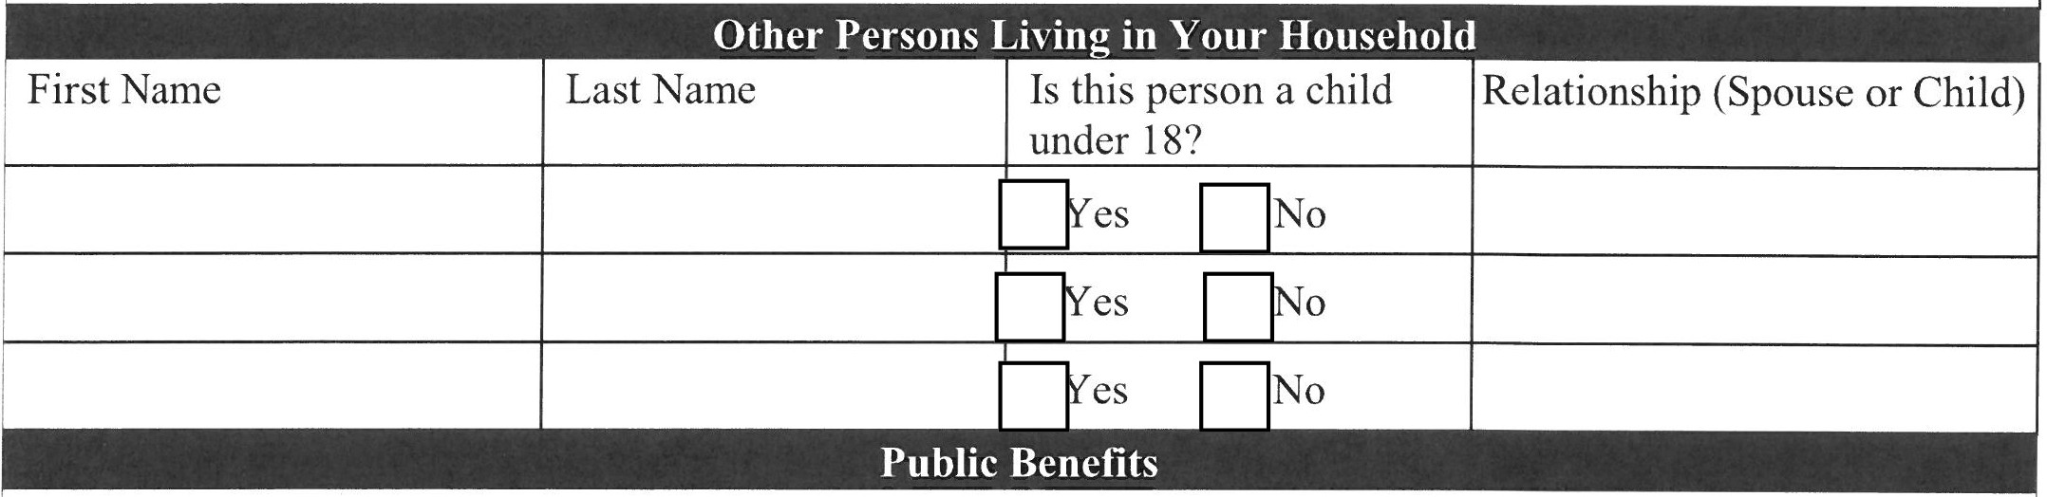

Ohio Works First1:D SSI2:D Medicaid3:0

I receive the following public benefits and my gross income, including the cash benefits marked below, does not exceed **187.5%** of the federal poverty guidelines.

Pace an "X" next to any benefits you receive.

Veterans Pension Benefit4:D SNAP/ Food Stamps5:

|  |  |
| --- | --- |
| Applicant's First Name | Applicant's Last Name |
| Applicant's Date of Birth | Last 4 Digits of Applicant's SSN |
| Applicant's Address | |

|  |  |  |  |
| --- | --- | --- | --- |
| I am **NOT** able to access my spouse's incom | | | |
|  | •  $ | Spouse (If Living n Household)  $ | Total Monthly Income  $ |
| Gross Monthly Employment Income, including Self-Employment Income  (Before Taxes) |
| Unemployment, Worker's Compensation, S ousal Support (If Receiving) | $ | $ | $ |
| **TOTAL MONTHLY INCOME** | | | $ |

**Pursuant to R.C. 2323.3ll(B)(3),** upon the filing of a civil action or proceeding and the affidavit of indigency under division (B)(**1)** of this section, the clerk of the court shall accept the action, proceeding, or motion for filing.

**Li uid Assets**

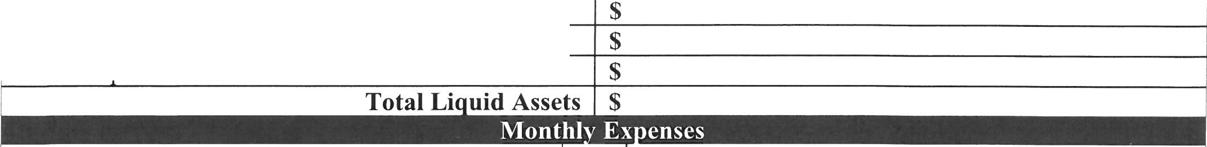

**T e of Asset**

**Estimated Value**

Available Cash in Checking, Savings, Money Market Accounts

Stocks, Bonds, CDs Other Li uid Assets

$

Cash on Hand

|  |  |  |  |  |
| --- | --- | --- | --- | --- |
| **Column A** | |  | **Column B** | |
| Insurance (Medical, Dental, Auto, etc. | **Amount**  $ |
| Rent *I* Mortgage *I* Property Tax *I*  Insurance | $ |
| Food *I* Groceries | $ | Child or Spousal Support that You Pa | $ |
| Utilities (Heat, Gas, Electric, Water *I* Sewer, Trash | $ | Medical / Dental Expenses or Associated Costs of Caring for a Sick or Disabled Farnil Member | $ |
| Trans ortation / Gas | $ | Credit Card, Other Loans | $ |
| Phone | $ | Taxes Withheld or Owed  **Total Column B Ex enses** | $  $  $ |
| Child Care | $ |
| **Total Column A Ex enses** | $ |
| **TOTAL MONTHLY EXPENSES** Column A+ Column B) | | | | |

I, ------------------, hereby, certify that the information I have provided on (Print Name)

this financial disclosure form is true to the best of my knowledge and that I unable to prepay the costs or fees in this case.

**NOTARY PUBLIC:**

Signature

Sworn to before me and signed in my presence this day of , 20

Notary Public

If available, an individual duly authorized to administer this oath at the Clerk of Court's Office will do so at no cost to the Applicant.

**ORDER**

D Upon the request of the Applicant and the Court's review, the Court finds that the Applicant **IS** an indigent litigant and **GRANTS** a waiver of the prepayment of costs or fees in this matter.

D Upon the request of the Applicant and the Court's review, the Court finds that the Applicant is **NOT**

an indigent litigant and **DENIES** a waiver of the prepayment of costs or fees in this matter.

**IT IS SO ORDERED**

Judge *I* Magistrate Date

**Pursuant to R.C. 2323.311(B)(3),** upon the filing of a civil action or proceeding and the affidavit of indigency under division (B)(l) of this section, the clerk of the court shall accept the action, motion, or proceeding for filing.